Innovative strength as a standard: For the fourth time in a row, Rittal receives the seal of approval
Rittal is again one of Germany’s Top 100 innovators
Herborn, 2025- 07-01
In 2025, Rittal GmbH & Co KG is once more one of Germany’s most innovative SMEs. In the renowned “Top 100” competition, the company was awarded the coveted seal for the fourth consecutive year – a testament to the sustainable and innovative strength of the largest company in the Friedhelm Loh Group. Artificial intelligence remains a key driver of innovation, both now and in the future.

“Innovation means acting and not reacting. This means actively shaping the future instead of hoping that nothing will change,” explains innovation researcher Professor Nikolaus Franke. The Top 100 competition has now been held for the 32nd time under his scientific direction. The innovative performance of small and medium-sized enterprises was analysed for the third time, based on over 100 criteria in five different categories. Rittal was particularly convincing in the “Innovative Processes & Organisation” category.

Digital intelligence for tomorrow’s industry
For years, Rittal has demonstrated how innovative solutions can drive sustainable growth. Together with sister companies Eplan and Rittal Automation Systems (RAS), Rittal is accelerating industrial automation, promoting digitalisation and increasing efficiency, increasingly with AI as an additional innovation booster.

Since being founded in 1961, Rittal has stood for the courage to change. What began with the standardisation of enclosures is now a global systems enterprise with strong software expertise. The early investment in Eplan over 40 years ago was a milestone: It laid the foundation for consistent, data-driven processes in industry. Now, this data, supplemented by AI, represents the key to the next level of industrial automation.

How innovation is driving industry forward
In panel building and switchgear manufacturing, Rittal, Eplan and RAS are accelerating the entire process chain with consistent data – from planning and designing to production with equipment and systems, through to operation. With industry expertise and advanced technology, the companies are thus increasing their customers’ competitiveness.

This is how concrete solutions make the difference today: The energy-efficient Blue e+ cooling units cut energy consumption during operation by up to 75 per cent. The RiLineX modular power distribution platform also reduces assembly time by as much as 75 per cent, a genuine boost to productivity. Rittal has developed a new Coolant Distribution Unit for future high-performance data centres that enables liquid cooling at the chip level, with over 1 megawatt of power, making it essential and trend-setting for AI applications. In the ultra-modern Smart Factory in Haiger, Rittal is also demonstrating how its own digitalisation innovations are being productively implemented and setting standards for Industry 4.0.

“Our solutions speed up work processes, reduce resource consumption, and ensure the competitiveness of our customers worldwide,” says Ulrich Engenhardt, Chief Business Units Officer at Rittal. “The Top 100 seal confirms this once more: We are on the right track with courage, digital intelligence and customer proximity.”

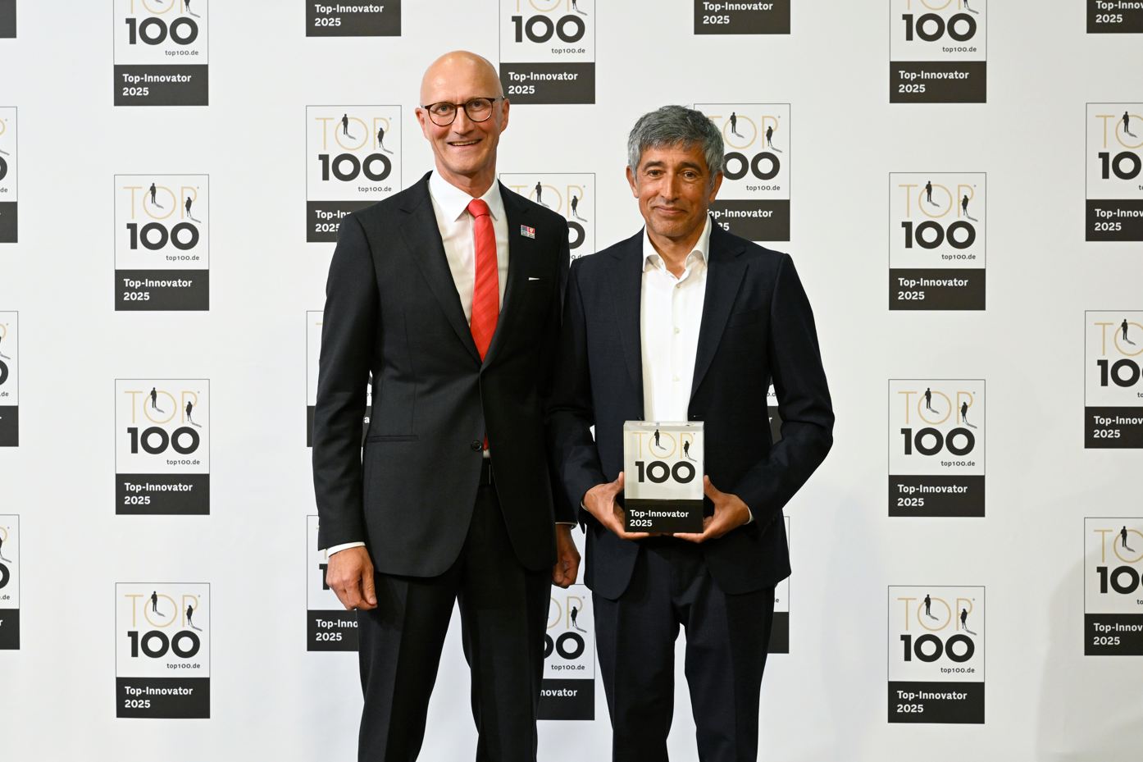 |  | 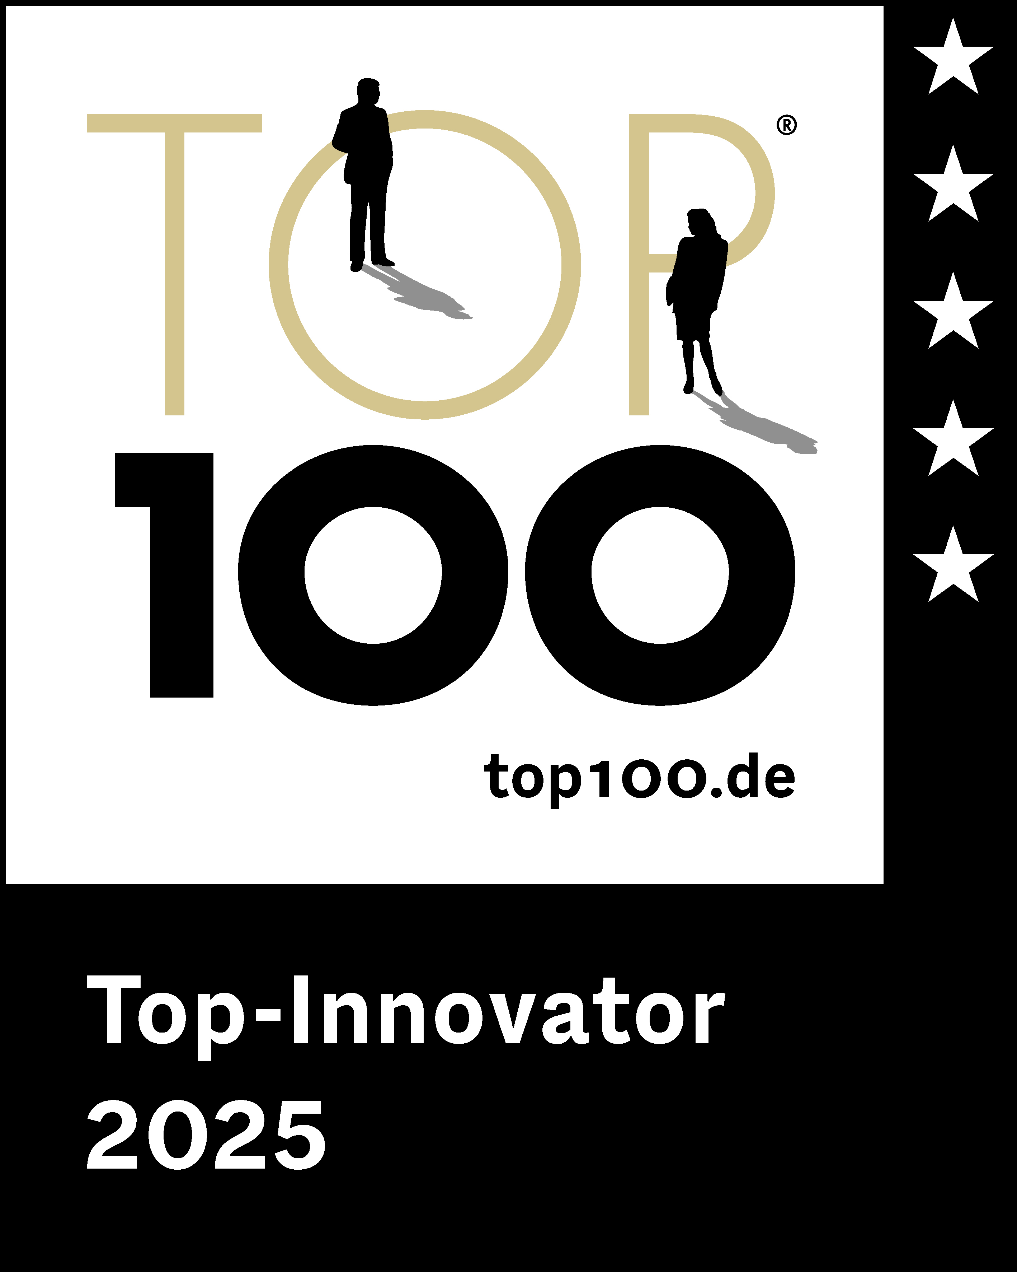
Image 1  Ulrich Engenhardt, Chief Business Units Officer at Rittal, accepts the award as a Top100 Innovator from the laudator Ranga Yogeshwar. |  | Image 2  In 2025, Rittal is once again one of Germany’s most innovative medium-sized companies and has been awarded the “Top 100” seal for the fourth consecutive year.

May be reproduced free of charge. Please name Rittal GmbH & Co. KG as the source

Rittal

Rittal is a leading global supplier of enclosure systems, automation and infrastructure with its industrial, IT, energy and power, cooling and service units. Rittal products and solutions are used in over 90% of global industries – standardised, customised, and always of the very best quality.

Our approach and methodology: Rittal, Rittal Software Systems (Eplan, Cideon) and Rittal Automation Systems (RAS, Ehrt, Alfra) combine their hardware and software expertise to streamline, optimise and industiralise processes across the entire value chain of their customers including their IT infrastructure – from control and switchgear construction, machine building to manufacturing companies or the energy sector.

Our delivery promise: Rittal standard products are delivered in Germany within 24 hours, and within 48 hours throughout Europe.
Customer focus
Improving efficiency and increasing productivity through automation and digitalisation is one of the biggest challenges for our customers. This requires in-depth knowledge and expertise, the combination of hardware and software, and cross-sector networking. We are convinced that creating and connecting data rooms is crucial to the success of industrial transformation. And that is exactly our speciality and field of competence.

Eplan and Rittal are driving the development of the digital automation twin, making data accessible and useable in operations as well. Cideon is improving data consistency in the digital product twin context with its CAD/CAM, PDM/PLM and product configuration expertise.
Sustainability
Environmental and climate protection, social commitment and ethical corporate management are a given for Rittal. We take our responsibility for a sustainable future seriously. Our approach to resource management and conservation involves continuous improvement of our own production processes and ensuring that our products have the lowest possible Product Carbon Footprint. Our solutions support our customers in achieving their own climate targets.
Family business and global player
Founded in 1961, Rittal is the largest company in the owner-operated Friedhelm Loh Group. The group operates worldwide, with 13 production sites and 95 international subsidiaries. It has 12,600 employees and posted revenues of 3.1 billion euros in fiscal 2024. In 2023, the Friedhelm Loh Group was presented with the “Best Place to Learn” and “Employer of the Future” awards. In 2025, Rittal was awarded the Top 100 Seal as one of Germany’s most innovative medium-sized companies for the fourth time in a row.

For more information, visit www.rittal.com and www.friedhelm-loh-group.com.

Corporate Communications
Dr. Carola Hilbrand Rittal GmbH & Co. KG
Corporate & Brand Communications Auf dem Stützelberg
Tel.: 02772/505-2527 35745 Herborn
hilbrand.c@rittal.de www.rittal.com

